Automation Setup

Table of Contents

Automation Setup 1

I. JDK Installation and Configuration 3

II. Eclipse Installation 10

III. Maven Set-up 12

IV. TestNG Set-up 19

V. Clone Repository 21

VI. Add the following folders in your local 25

# JDK Installation and Configuration

1. Download JDK from this link: <http://www.oracle.com/technetwork/java/javase/downloads/jdk10-downloads-4416644.html>
2. Click Accept License Agreement and download jdk.

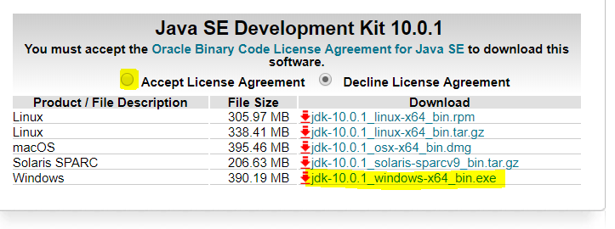

1. Open the location folder for jdk. Double click or right click on the Java application installer *(Sample installation file name: jdk-8u162-windows-x64.exe)* then click Open. (Click Ok when prompted when installing the file.)



1. 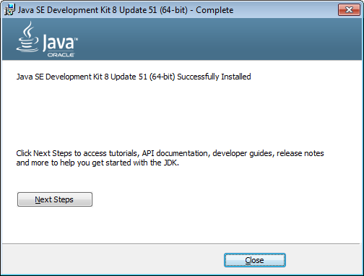Progress and wait until the application is successfully installed.
2. Once copied successfully, navigate to Start > Enter ‘This PC’ > Right Click ‘This PC’ > Right Click ‘Properties’

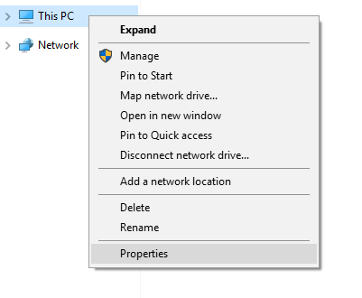

1. Once the ‘System’ screen appears, click ‘Advanced System Settings’*. (You can only access this if your current machine has the Administrator rights enabled for your User)*

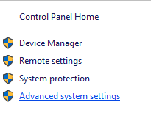

1. Once the ‘System Properties’ dialog box appears, click ‘Environment Variables…’.

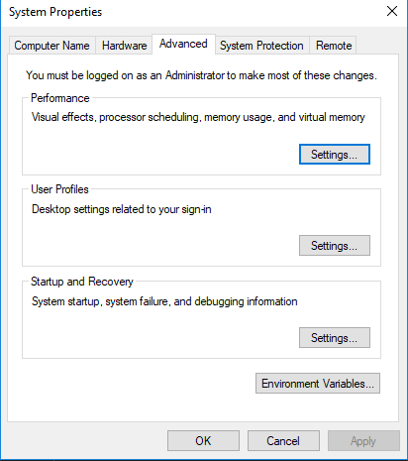

1. Once the ‘Environment Variables’ dialog box appears, click the ‘New…’ button under the ‘System Variables’ section.

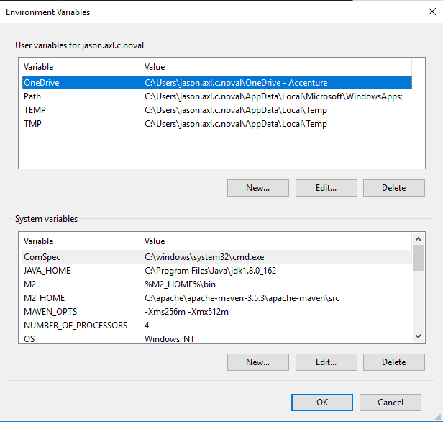

1. Once the ‘New System Variable’ dialog box appears, enter the value **“JAVA_HOME”** as the **Variable Name** and the **file path** (e.g. “C:\Program Files\Java\jdk.1.8.0_162”) where the JDK was installed on the **Variable Value**. Then, click OK button.

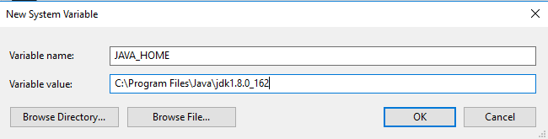

1. Look for the variable name **“Path”** under the **system variables section** then click the Edit button.

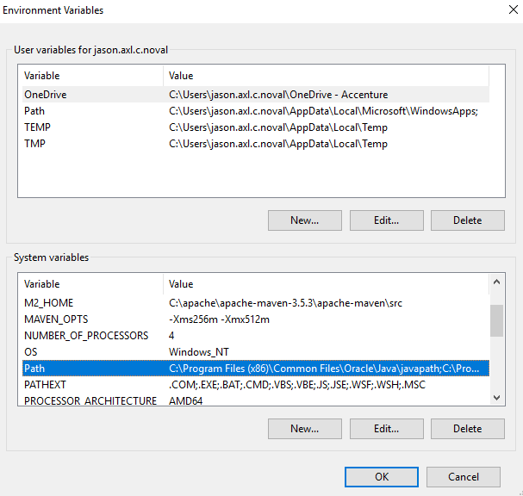

1. Once the “Edit System Variable” dialog box appears, add the **“;%JAVA_HOME%”** in the end of the Variable Value field. Then, click OK button.

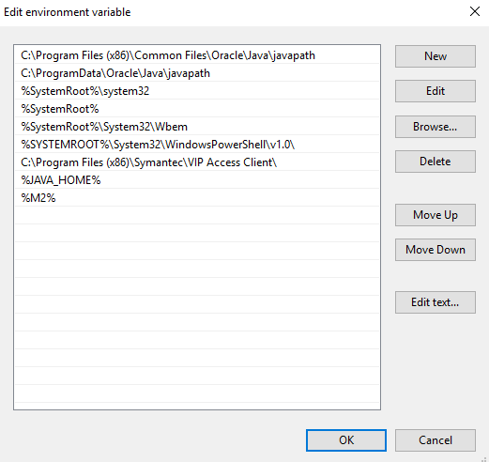

1. Once done, navigate to Start Menu and type “CMD” (or Command Prompt) in the Start Menu search bar. This will open the command prompt.
2. Enter **“java -version”** and validate if you get the same results as indicated on the screenshot below. Once you’ve get the same results (***output includes the java version***), this means that the JDK is successfully configured for our set-up of Selenium Webdriver.

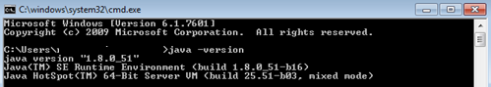

1. Close the CMD/Command Prompt.

# Eclipse Installation

1. Download Eclipse App in link <https://www.eclipse.org/downloads/>
2. Click download 64-bit

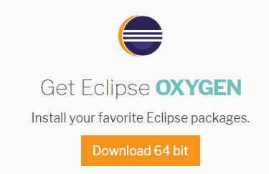

1. Run the file as admin

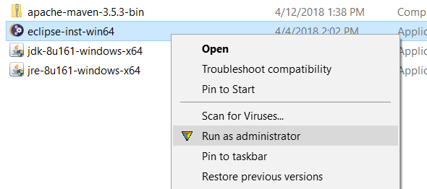

1. Select Eclipse IDE for Java Developers

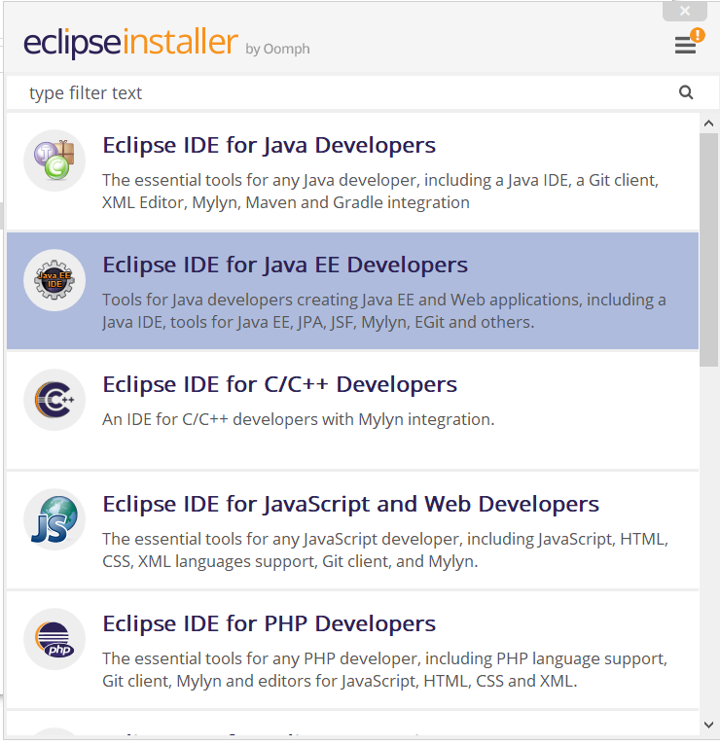

1. Click install

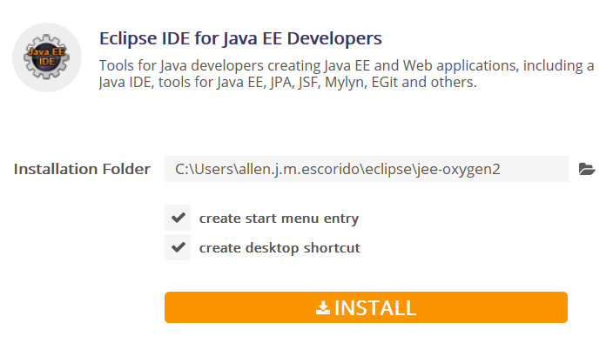

1. Click accept

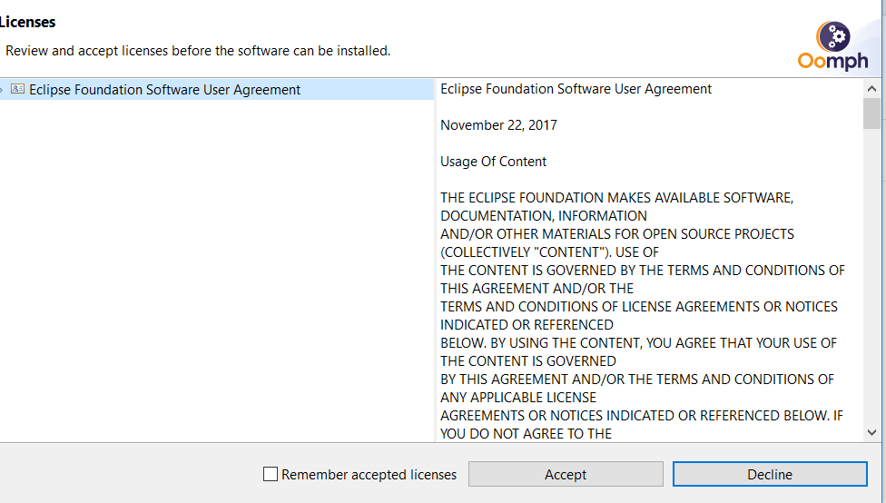

# Maven Set-up

**INSTALLATION:**

1. **Maven Configuration**
2. Download the Apache Maven in this [link](https://maven.apache.org/docs/3.6.1/release-notes.html) and extract it afterwards.
3. Copy Maven file in Drive C > Program Files

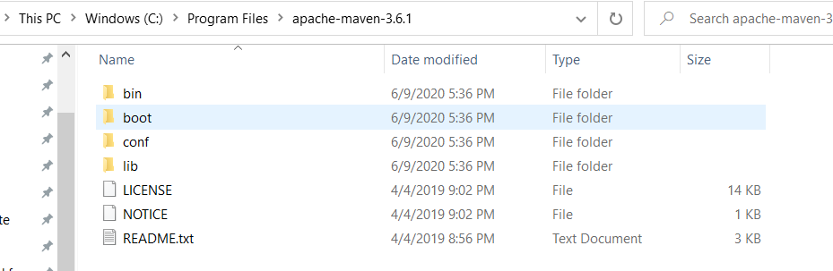

1. Once copied successfully, navigate to Start > Enter ‘This PC’ > Right Click ‘This PC’ > Right Click ‘Properties’



1. Once the ‘System’ screen appears, click ‘Advanced System Settings’*. (You can only access this if your current machine has the Administrator rights enabled for your User)*



1. Once the ‘System Properties’ dialog box appears, click ‘Environment Variables…’.



1. Once the ‘Environment Variables’ dialog box appears, click the ‘New…’ button under the ‘System Variables’ section.



1. Once the ‘New System Variable’ dialog box appears, enter the value **“M2”** as the **Variable Name** and the “**%M2_HOME%\bin**” as the **Variable Value**. Then, click OK button.

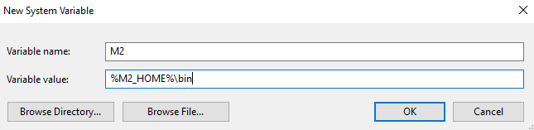

1. Click the ‘New…’ button again under the **System Variables section.**
2. Once the ‘New System Variable’ dialog box appears, enter the value **“M2_HOME”** as the **Variable Name** and the **file path** (e.g. “C:\Program Files\apache-maven-3.6.1) where the maven was stored on the **Variable Value**. Then, click OK button.

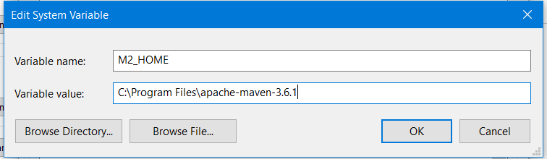

1. Click the ‘New…’ button again under the **System Variables section.**
2. Once the ‘New System Variable’ dialog box appears, enter the value **“MAVEN_OPTS”** as the **Variable Name** and the “**-Xms256m -Xmx512m**” as the **Variable Value**. Then, click OK button.

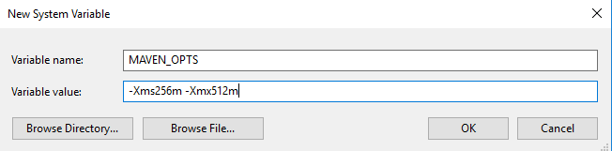

1. Look for the variable name **“Path”** under the **system variables section** then click the Edit button.

c

1. Once the “Edit System Variable” dialog box appears, click “New” and add **“%M2%”.** Then, click OK button.

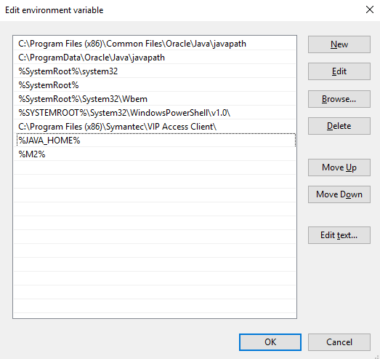

1. Once done, navigate to Start Menu and type “CMD” (or Command Prompt) in the Start Menu search bar. This will open the command prompt.
2. Enter **“mvn --version”** and validate if you get the same results as indicated on the screenshot below. Once you’ve get the same results (***output includes the maven version and file path and java version***), this means that the maven is successfully configured for our set-up of Selenium Webdriver (together with JDK setup).

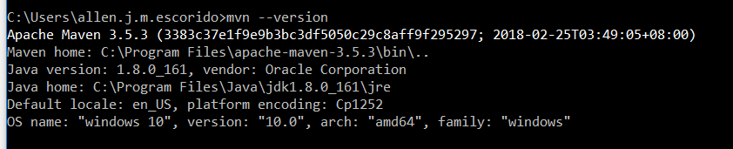

# TestNG Set-up

1. On the menu bar of Eclipse, click “Help”.

2. Select the “Eclipse Marketplace…” option.

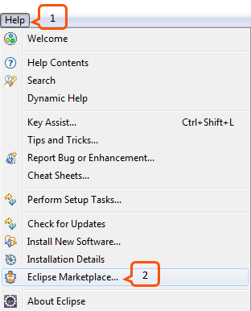

3. From the Search Tab type “TestNG” on the search box and press enter.

4. Click Install button.

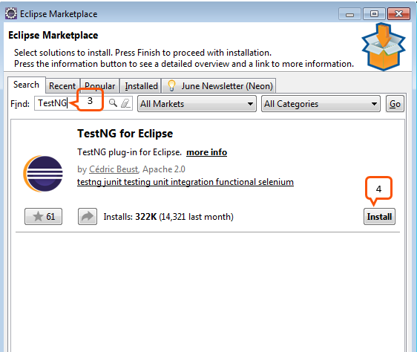

5. Click Confirm button on the next window.

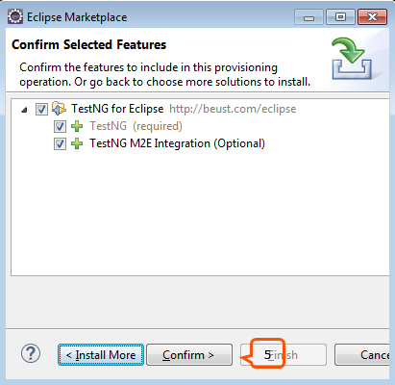

1. Select option: “I accept the terms of the license agreement” then click Finish button.

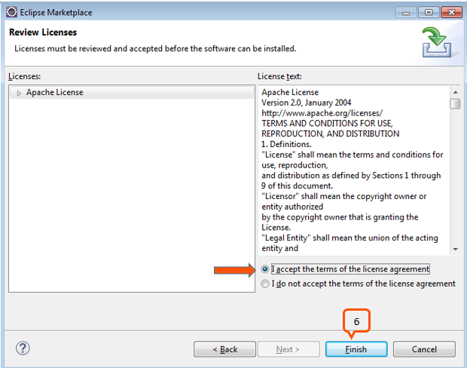

1. Wait for the software to install.

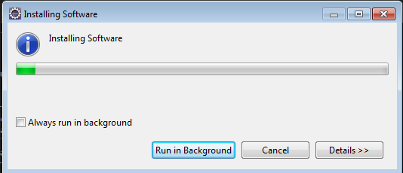

1. Click Yes button to restart Eclipse.

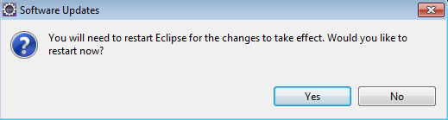

# Clone Repository

1. Open Eclipse and click Window > Perspective > Open Perspective > Other.

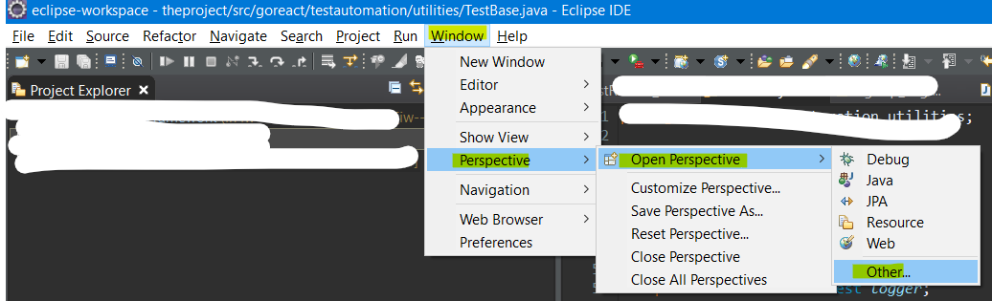

1. Select **Git** and click Open

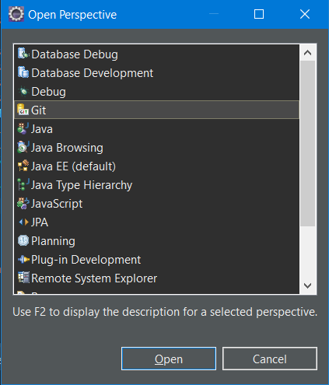

1. Click **Clone a git repository** icon  
   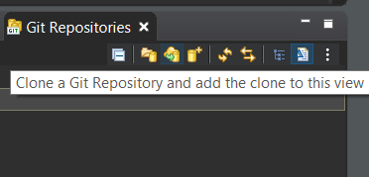
2. Enter <https://github.com/camillelouiegit/theproject.git> in the URL.

Enter local credentials in the Username and Password and click Next.

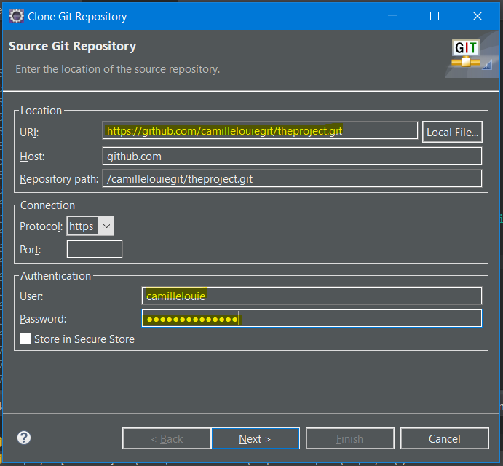

1. Uncheck **main** and click Next.

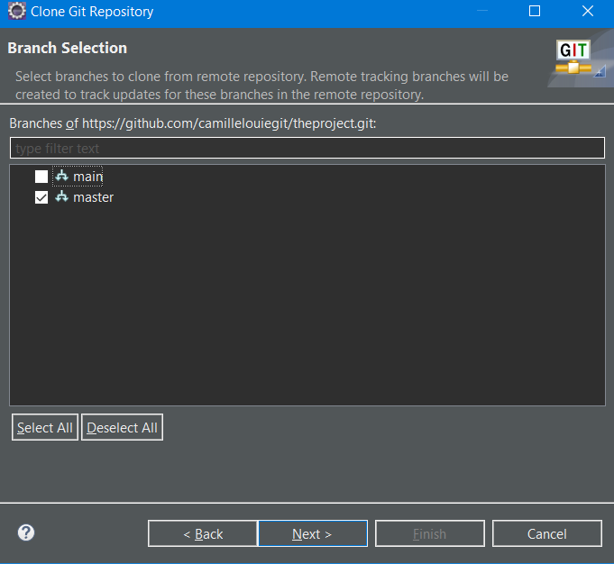

1. Then click Finish

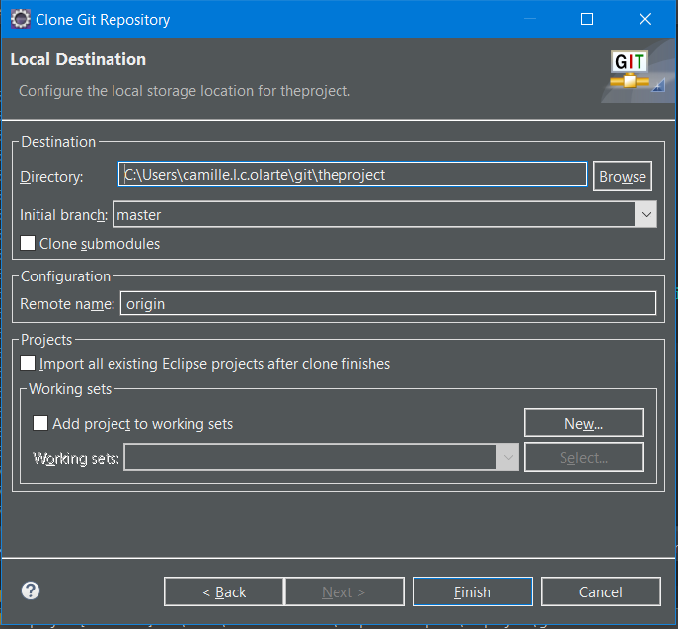

1. Once clone is done. Right click on the Repository and click Import Project

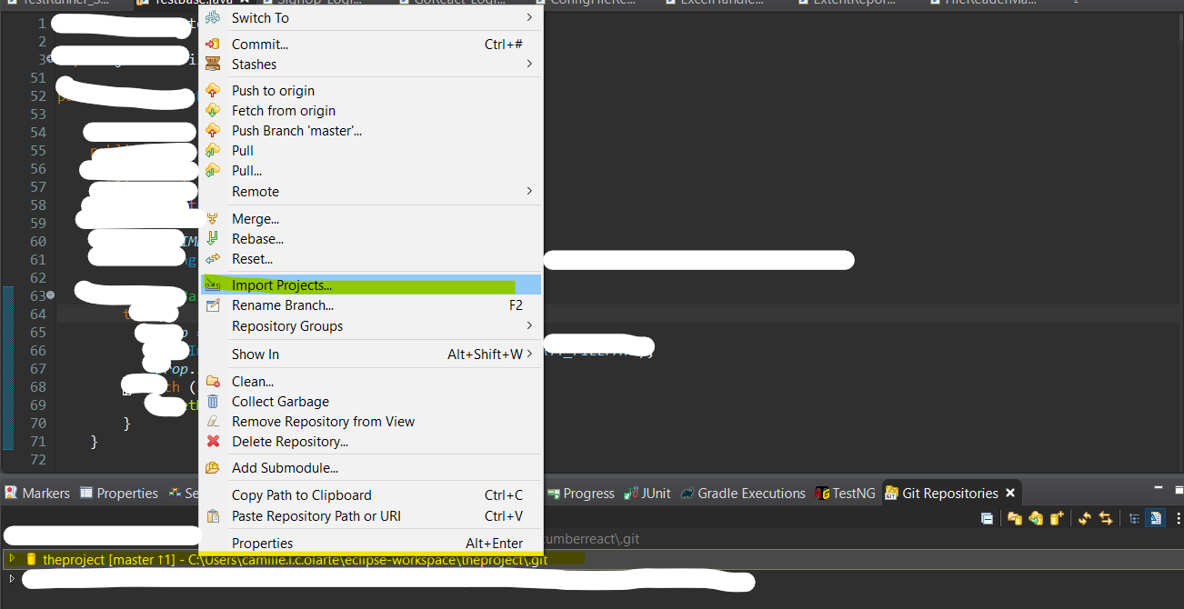

1. Check “the project” folder and click Finish

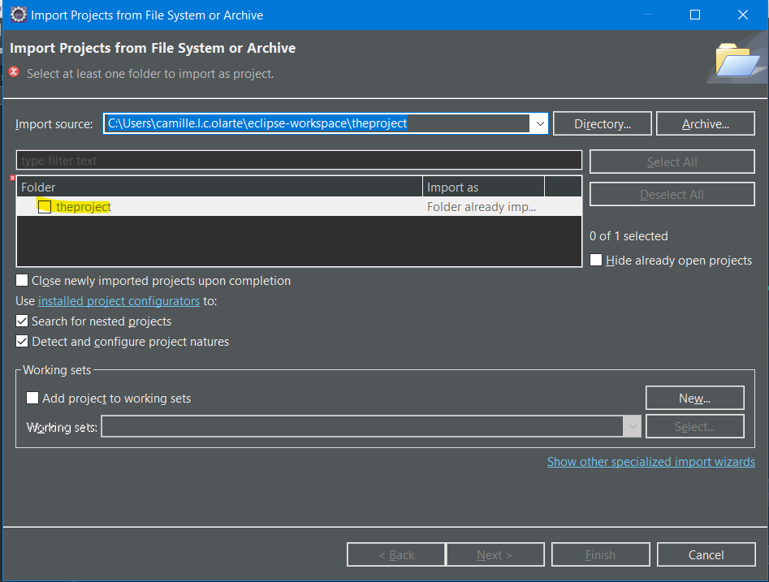

1. The project should reflect in the Project Explorer

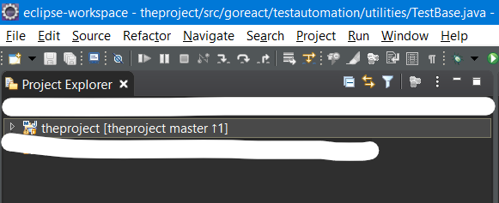

# Add the following folders in your local

1. Navigate to this file path: *C:\Users\(localuser)\AppData\Local\Google\Chrome\User Data*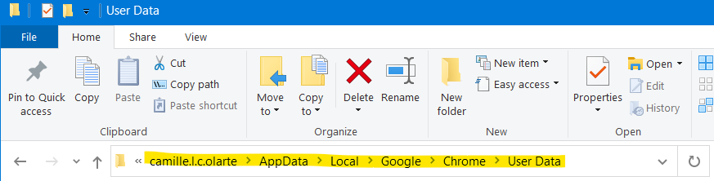
2. Create **automation** folder

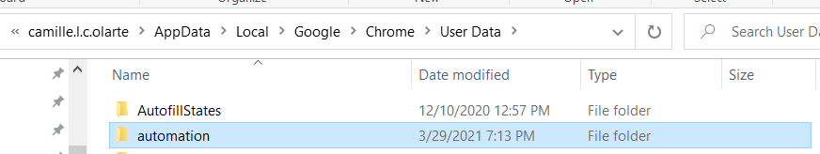

# BDD Selenium Cucumber Set-Up

1. Follow the steps in the PowerPoint document.



# Running the theproject test suite.

1. Open eclipse and navigate to:

*theproject > goreact.testautomation.testRunner > TestRunner_SignUp_Login.java*

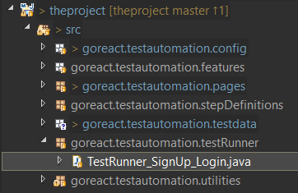

1. Open *TestRunner_SignUp_Login.java*

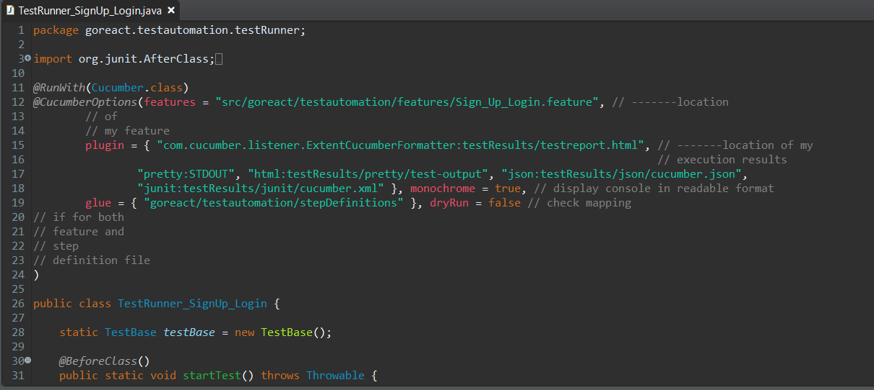

1. Right click inside the java file and click Run As > Junit Test

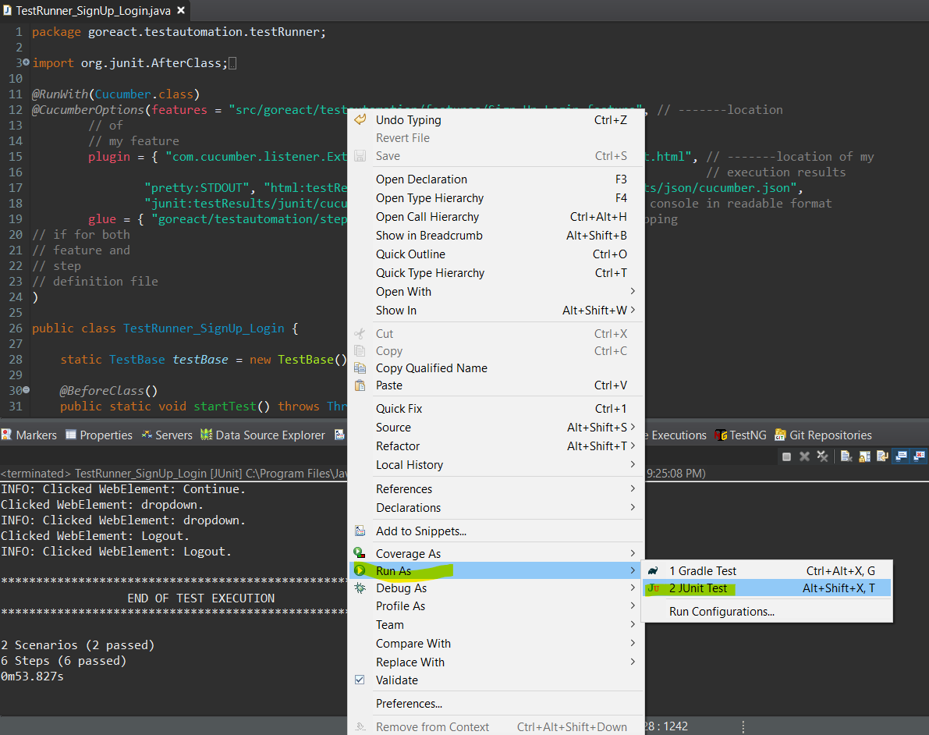

1. Test automation should start and details are shown in the console.

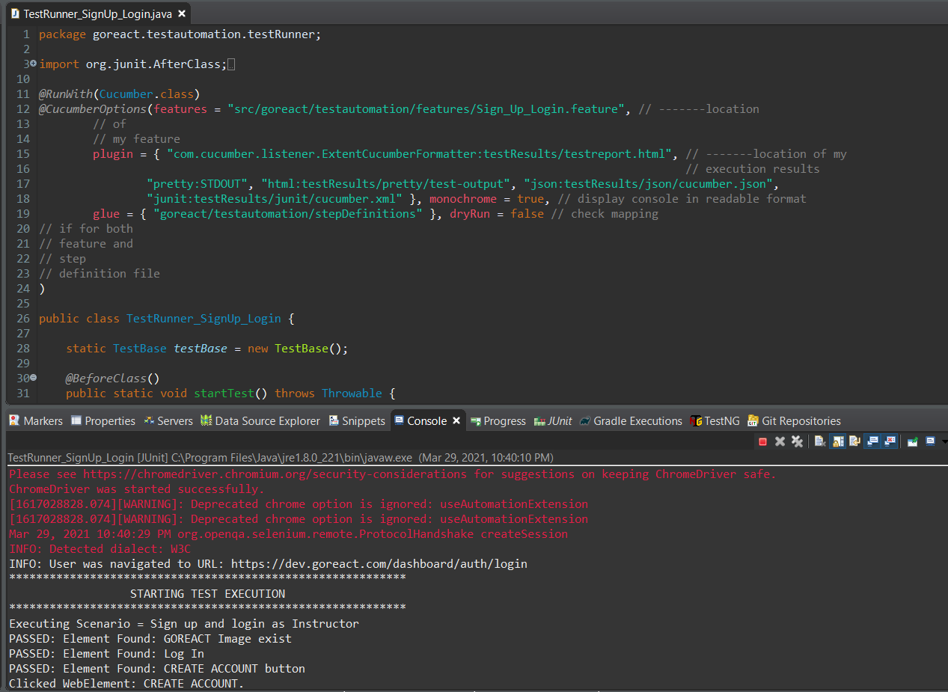

1. Wait until the test execution is completed. Then click **Yes** to close the browser **No** to remain open.

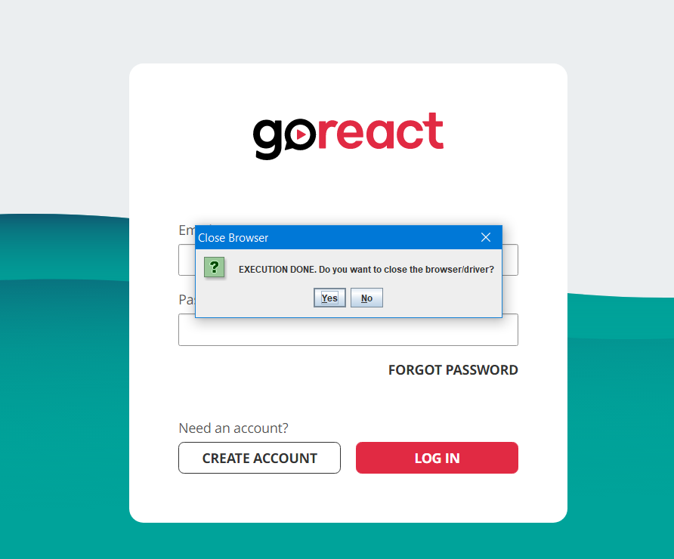

1. Navigate to: theproject > testResults > extentReports > Report.html

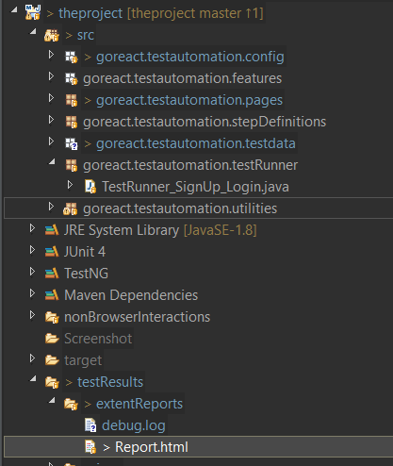

1. Double click Report.html

